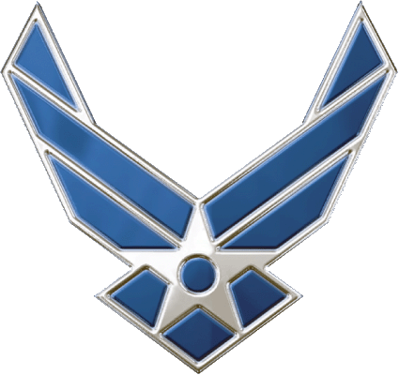
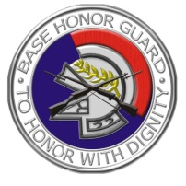
Niagara Falls ARS Honor Guard
E-Mail/Fax Request for Color Guard Support
Phone: (716) 236-3182
Fax: (716) 236-3578
E-Mail: 914aw.honorguard@us.af.mil
DO NOT USE FORM FOR FUNERAL HONORS

Background: The Niagara Falls Honor Guard supports military funeral honors and color guard support for events throughout most of Western New York. You can make military funeral honors requests by phoning (609) 754-4117 and speak to a Mortuary Affairs representative. To make requests for color guard support, please complete this form and e-mail/fax to the above email/fax number. Requesters should be advised that we prioritize events using the following criteria: (1) all military funeral honors, (2) official military functions (prioritized by date of request), (3) all other requests for support (prioritized by date of request). Our decision to cancel support for events is based on manpower and workload. In those rare circumstances where we simply cannot support, we will make every effort to give you as much advanced notice as possible. E-Mail Instructions: (1) Open this form and fill in all blocks as appropriate. (2) Save the form as you would any other document and create a unique name (ex: Warner Retirement Ceremony, Buffalo Bills Football Game, and etc.). (3) Attach the new document to an email message to 914aw.honorguard@us.af.mil. (4) Use the subject line “Request for Honor Guard Support” to flag your message. You will receive an e-mail response or phone call once your request has been opened. Requesters are advised to ensure accurate and detailed information on this form, as our support for your event will be based on this information disclosed herein. For events outside of the Niagara Falls ARS, detailed event information and addresses are critical along with an accurate description of the event location and desired ceremony. Thank you for your request and we look forward to supporting your organization.

Name of Event Date of Request
(A brief description such as “CMSgt Smith Retirement”) (DD MM YYYY)

Point of Contact (POC) Name POC Phone Alternative Phone POC Organization
(Include military rank if applicable) (Include Area Code) (Include Area Code)

Date of Event Start Time Street Address of Event City/Zip Code
(DD MM YYYY) (HH:MM) (Give nearest cross-street if address is unavailable)

Support Requested: Present Colors: (U.S. & AF flags) are marched into the event for the playing of the National Anthem. Post Colors: colors are marched in and “posted” to flag stands for duration of event.
Parade: typically, we provide two riflemen, a U.S. and Air Force flags. Other options upon request.
POW/MIA Ceremony
Flag Folding Ceremony

Description of Events/Special Instructions or Requests: (please be as specific as possible to include dignitaries and special requests for composition of the color team members – ex: all members from a particular squadron, by name and etc.)

Directions to the Event from the Niagara Falls ARS, NY 14304 (please be as accurate as possible and include estimated drive time):

